Static Water Bending

Subject:  Related Subjects: Static Electricity | Grade Level(s): 6, 7, & 8  Length of Lesson: 71 minutes | Type: Inquiry / Design / Project  Keywords: Electron, Static, Repulsion, Polarity

Lesson Overview
Students will team up to observe the effects of static electricity on a polar molecule like water. They will learn the concepts of attraction, repulsion, friction, polarity, and charge.

Lesson Focus
What is the central question or phenomenon being investigated? What problem are they trying to solve?

Lesson Objective(s) | By the end of this lesson, students will…  - Learn the concepts of attraction, repulsion, friction, polarity, and charge.

Lesson Timing

Time [min] | Description
5 | Introduce the Lesson  - End Goal  - Primer Questions  - Key Vocab Words
1 | Role Models in STEM
Engineering Method
5 | Real World Example
5 | Hypothesis & Prediction
5 | Brainstorm & Design
20 | Build & Create
10 | Test & Record
5 | Assess & Evaluate
5 | How to improve?
10 | Lesson Cleanup

Materials | - Plastic Cups (10)  - Access to water  - PVC piping (10 1.5-inch long pieces of any diameter)  - Microfiber Cloth (10 palm-sized squares)  - Wood Planks/Stand (10)  - Bucket (1)  - Aluminum Cans (10)
Instructor Prep | - Step 1
Related Resources | - List related lessons/ppts etc available from USC or outside, trusted orgs

Lesson Plan

Introduction
- What is an electron?
  - A subatomic particle
  - Part of an atom
  - Negative charge
- What does it mean for something to be static?
  - Not moving
- What is polarity? Where can we see it?
  - Having 2 or more poles or charged ends
  - North and south poles
  - The Earth, magnets, electronic components

Procedure
- Using a pushpin poke a hole in the bottom of the plastic cup.
- Fill a water bottle with water.
- Place an empty bucket to catch the running water on the floor or countertop.
- Pour water into the plastic cup with one’s finger coving the hole at the bottom.
- Have a partner measure 3feet away from the bottom plastic container.
- Have that partner than repeatedly rub a piece of PVC pipe with a cotton cloth.
- Have the partner, whom is holding the cup release their finger and let the water flow.
- Bring the now charged PVC pipe toward the running water and observe that distorted path.
- Repeat the prior steps using a different fabric.

Wrap-up
The purpose of the survey is to let us know your opinions about today’s project. Remember there are no right or wrong answers.

 |  | Strongly Disagree | Disagree | Undecided | Agree | Strongly Agree
1 | The project increased my interest in science
2 | After this project, I am more confident in doing science

3. What kind of scientist studies electricity?

4. What is grounding?

5. Draw a picture of a water molecule.

Lesson Background for Teachers

Suggested Real-World STEM Connections

Real World Example
- A real world example of static electricity is feeling a shock when touching a metal doorknob. You feel the shock because the electricity is being grounded.

Hypothesis & Prediction
- Students will hypothesize which materials provided cause static electricity that caused the water to bend.

Brainstorm & Design
- What will the students be brainstorming solutions to?
- Have students identify what constraints they have. (Time, materials, etc)
- How will they overcome those constraints?

Build & Create
- The students will build a simple device to demonstrate static electricity.

Test & Record
- Students will describe the trajectory of the water.

Assess & Evaluate
- Students will assess the degree of success based on whether the water bends.

How to Improve?
- Students will brainstorm a list of ways to increase the effect of static electricity if the trajectory of the water is straight.

Lesson Variations and Options
Include descriptions of alternative methods or ways to present things.

Explanation
Once static electricity has been generated, putting the charged object next an object of a different charge attraction or repulsion occurs.

Key Concepts and Vocabulary
- Electron
  - A negatively charged particle.
- Static
a. An imbalance of electric charges within or on the surface of a material.
- Repulsion
  - The tendency for things to move away from each other
- Polarity
  - The property of having poles or being polar.
- Lightning
  - A sudden electrostatic discharge that occurs during an electrical storm. This discharge occurs between electrically charged regions of a cloud or the ground.
- Friction
  - The resistance that one surface or object encounters when moving against another.

Safety Notes
- Safety instruction

Role Model in STEM

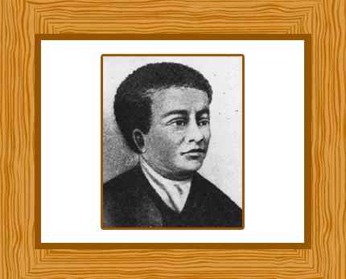

Name: Benjamin Banneker
Years: 1731-1806
Quick Facts
- African American astronomer, mathematician, and author who constructed America’s first functional clock

Source(s):
- https://www.famousscientists.org/15-famous-black-scientists-in-history/

